
BIG on TOUR 2026 FINAL
Saturday 29th AUGUST
Bedford International Athletics Stadium

«First_Name» «Surname»
«Email»

Dear «First_Name»
Thank you for your entry to the FINAL of this new and innovative 2026 series of BIG on TOUR.
We have loved how this series has developed and how some of you have used it as a stepping stone to Championship success and thank you for your support. Over the season we have seen
- Athletes selected for the Commonwealth Games (25), Euro U18’s (7), World Juniors (7) and European Champs (14)
- At the UK Trials Joel Clarke-Khan (HJ) and Archie Yeo (LJ) both achieved European Qualification marks
- 23 Meeting Records have been set, 4 Championship Qualification Marks achieved and over 30 Personal Bests shattered
At this stage of the season, with no championships to focus on, we hope that you will take this opportunity to ENJOY competing just for YOU, aim for a PB, but mostly please have FUN in an athlete friendly environment where YOU are the priority and the focus!
EVENT : «Event» POOL: «Pool»
TIMETABLE
10:30 High Jump Pool B
10.30 Long Jump Pool B
12.10 Long Jump Pool A
12.30 High Jump Pool C
14.00 Long Jump Pool C
14:30 High Jump Pool A
14.00 Long Jump Pool C
15.15 Triple Jump ALL

A Final Timetable, Event Pools will be at https://www.bedfordgames.co.uk/bedfordfinal6 . Please check carefully before the day as there may be minor movements from one Pool to another. You will not be contacted regarding these changes. It is your responsibility to check.
If you are in more than one event you will receive separate emails. We have tried our best to ensure “double ups” are possible but if you were in more than one event and these clash, please can you let me know immediately which you wish to do.
You will find more details on the BIG on TOUR Bedford page as well as on Entry4sports.com.
Please also READ everything below as there is a lot of information we need to pass on to you.
It is IMPORTANT that you check over the next few days for any updates to Pools or Timetable. If any of the above details are incorrect, please contact me as a matter of URGENCY.
If you need to WITHDRAW from this competition, please email bigontour@outlook.com as soon as possible, as we have a reserve list in all events. You CANNOT withdraw via the E4S site. No REFUNDS will be issued.
BIG on TOUR is a unique event in the Fixtures calendar and was born to provide good quality High Jump and Long Jump competition in the UK which has been badly lacking over the last few years. 2026 is our Pilot year and we are learning too, so any constructive comments or suggestions will be gratefully received as we look to develop over the series. All necessary equipment (EDM, No Jump cameras, screens, etc) will be in situ to ensure that performances can be ratified.
Events on the day are being overseen by highly qualified Officials ably assisted by a small number of Development Officials as we provide a mentoring process to assist them in their journey to working at High Level competitions.
The meeting is a World Athletics Ranking Competition 2026 and has a UKA Level 2 and WPA permit and will be run under WA Rules.
PLEASE NOTE: Spike lengths will be checked at the competition site. Pyramid or Christmas Trees only will be allowed – DEFINITELY NOT NEEDLE SPIKES or any that are sharp at the tip!!!!!
High Jump Max 9mm
Long Jump Max 6mm

CAR PARK – Parking for athletes, coaches & spectators is available in the Car park area to the Left on entry or on the field. There is plenty of space and it is FREE of charge to all
ATHLETE ENTRY to the stadium will be via the Main Stadium entrance
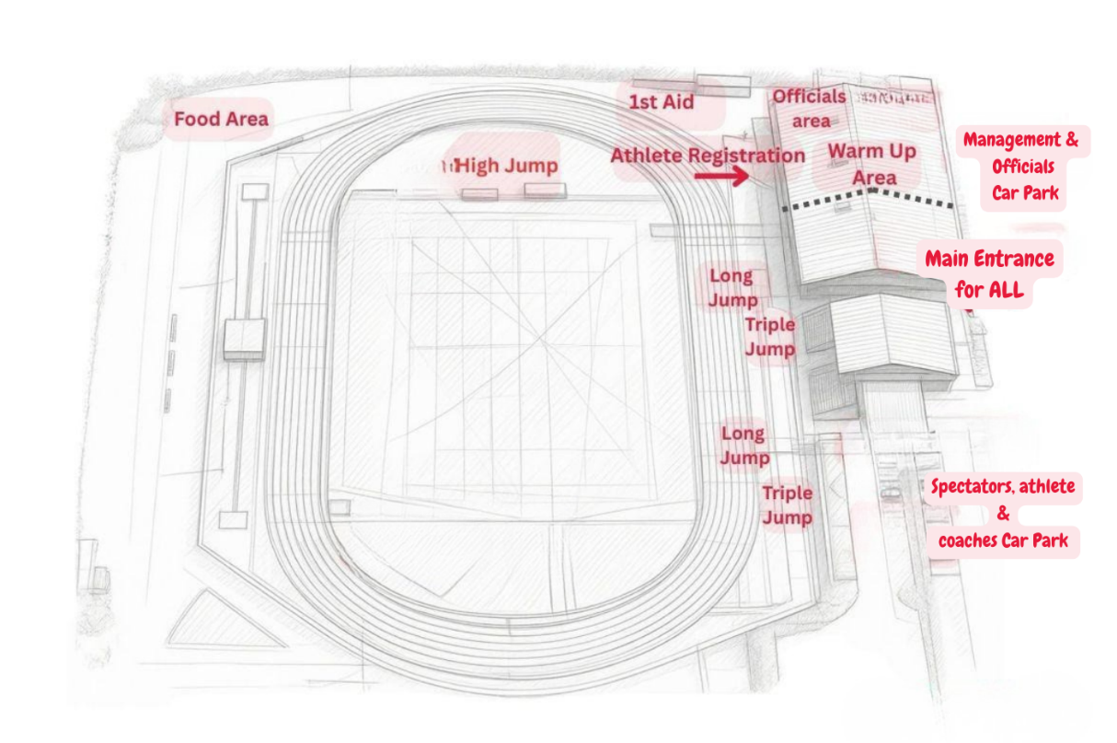Bedford Site Plan

ATHLETE REGISTRATION DESK – will be situated at the bottom of the Ramp to the Indoors Area
You must register and collect your Bib at least 60 minutes before your event.
WARM UP AREA – You may use the track or the indoor area for warm up.

COACHES PASSES – There is no need to register in advance for coach accreditation. Please go to the Athlete Registration Desk on Arrival and register there. Please leave your email address and licence details on the form available so we may contact you for future events. Please collect a wristband as Only those with a wristband will be allowed in the Coaching areas
DISALLOWED EQUIPMENT IN THE COMPETITION AREA – Athletes are reminded that mobile phones/ iPods, Smart watches, Tablets, cameras, etc must not be taken into the competition area and this will be checked at your event site.
REPORTING for your Pool – There will be no FINAL CALL area so please go directly to your competition area 30 minutes before your event start time to begin technical warm up as it will take time to mark & set up run-ups etc. All spikes, kit, disallowed equipment, etc will be checked at your competition site. PLEASE make sure the previous competition has finished before going to your site
SPECTATOR & COACHING AREAS – As there are no track events it will be possible to get closer to the event sites and these areas will be roped off. COACHES AREAS will be designated near all event sites so can you please ask your coaches to adhere to them. When walking between events, please walk round the outside of the track. No seating is available near the HJ area so we advise bringing your own chairs
Just a reminder for all athletes and coaches: although we've relaxed the restrictions on where coaches can stand, athletes must remain within the competition area during their event, and coaches need to stay on their side of the barrier.
In other words: athletes inside the barrier, coaches outside the barrier!!!! THANK YOU.
HIGH JUMP
  - Competitions have been split by performance not gender and two cards (Men & Women) will be run where necessary to make the competition legal.
  - Progressions will be decided before the competition and we will look to go through as many of the relevant qualifying standards as possible. We will also ensure starting heights & progressions in each Pool are suitable for this time of the season.
  - We will ensure the first height in each competition is comfortable for all.
  - Call up will be 30 mins prior to start time. Call up will be at the High Jump area. PLEASE make sure the previous competition has finished before going to the site
  - LONG JUMP
  - The competitions have been split by performance not gender and two cards (Men & Women) will be run where necessary to make the competition legal.
  - All competitions will be measured by EDM with Electronic No-Jump equipment also in use.
  - All athletes will have 6 Trials.
  - PLEASE NOTE: There will be NO reversal of the jumping order after Round 3.
  - Call up will be 30 mins prior to start time. Call up will be at the Long Jump site. PLEASE make sure the previous competition has finished before going to the site
      - TRIPLE JUMP
  - There is just one competition and two cards (Men & Women) will be run where necessary to make the competition legal.
  - All competitions will be measured by EDM with Electronic No-Jump equipment also in use.
  - All athletes will have 6 Trials.
  - PLEASE NOTE: There will be NO reversal of the jumping order after Round 3.
  - Call up will be 30 mins prior to start time. Call up will be at the Triple Jump site.
SEATING – There is spectator seating by the Long / Triple Jumps but nothing by the High Jump so we suggest you bring your own seats.
MEDICAL COVER – First Aid cover will be present.
WATER – There is a water fountain and vending machine in the stadium.
REFRESHMENTS – A Coffee Van and Food Truck will be serving hot and cold food and drinks all day. An Ice Cream van may be there, weather dependent. A link to the menu for the Food Truck can be found below but in addition they will be doing Specials of such as Sandwiches, Rolls, Salad Bowls, etc.
https://acrobat.adobe.com/id/urn:aaid:sc:EU:fa9c385c-a0e8-42b2-85ba-b5681df6492e
BIG cannot accept responsibility for incurred expenses should the meeting be cancelled or postponed, nor can BIG accept responsibility for any injury or loss incurred at this event.
BIG reserves the right to decline entry to any person unable to meet or abide by the promoter’s conditions.
Please do not hesitate to contact me on the number below or by email if you have any further questions. We look forward to seeing you on August 29th and to a great day of HJ, LJ & TJ competitions as we celebrate a very successful 2026 BIG on TOUR series and some amazing performances from athletes over the summer.
With best wishes,
Carol Jackson
Meeting Director
07850 190299

To be found at https://www.bedfordgames.co.uk/bedfordfinal6 and at E4S from Wednesday 26th August
Timetable Event Pools with timings Updates

