

BIG on TOUR 2026 FINAL
Saturday 29th August
Bedford International Athletics Stadium

Jackie Breslin
Field Referee
jackiebreslin22@googlemail.com

Dear Jackie

Many thanks for agreeing to officiate at the FINAL event in the BIG on TOUR 2026 series. I would like to thank you for supporting us over the piloting of this very exciting initiative to help provide good quality competition for High Jumpers & Long Jumpers in a fun, friendly and well officiated environment.

You can find much more on www.bedfordgames.co.uk and follow the BIG on TOUR links. Please be assured we are a friendly group, working for the best athlete experience possible and will provide training in the use of EDM, Wind Guage, No Jump cameras and IPad results input should this be required by our less experienced officials.

BIG on TOUR is a series of 6 competitions focussing on only High Jump & Long Jump and spread throughout the South & Midlands over the whole of the summer concluding with this Final at Bedford on 29th August (more details can be found on the BIG on TOUR section of our website if you would like to know more). The response to the series has been extremely positive from athletes & coaches alike. It has filled a gaping hole in this area and we are very proud to see many of our athletes competing at European Champs in Birmingham, World U20’s in Oregon and European U18’s Champs in Rieti, Italy.

We have been given a Level 2 Permit and World Ranking point Level F as well as WPA status.

The events this time are High Jump and Long Jump but also Triple Jump at the request of athletes. As is our trademark, BIG on TOUR will also be an athlete friendly meeting with coaching areas close to the events (roped off for safety of course).

We are PILOTING the TOUR this year with some new procedures or protocols you may not be familiar with so things may be a little strange or crazy at times but here are a few things I think it would be good for you to know.
- There will be no CALL UP area – athletes will report to their event site 30 minutes before their Pool start time.
- Please can the Chiefs of each competition check athletes spike length, disallowed equipment, etc. at the event site.
- We have Lead Officials whose responsibilities will be MM , FR & EO before the meeting and they will return to Field Judges when we begin. These officials and others present have worked with us at BIG before and know the protocols and will be there to act as Mentors to any new officials we have.
- We have also invited a small number of Level 1 and Level 2 officials to work alongside us in a high level competition environment & work with technical equipment (Tablet recording, No Jump Cameras, EDM, etc) which they may be unfamiliar with. Training will be given on these as required.
- Technical equipment will be around the stadium (touch screens, electronic scoreboards, etc).
- All results will be recorded on Tablets and these will go directly to electronic scoreboards at each event, the bigger screen around the arena and Power of 10.

All final paperwork (Officials list, Timetables, Entry lists and Athlete letter) will also be available through the https://www.bedfordgames.co.uk/bedfordfinal6 (look at the drop-down boxes to the top Right of the home page or go via the button on the home page) and will be amended / added to as appropriate so please recheck regularly.

LEAD OFFICIALS - We have identified the following Leads to start and close the event. However they will return to Field / Mentoring roles once the event begins

Claire Lacey (MM) Jackie Breslin (FRef)

CAR PARK – There is plenty of space in the car park to the front of the building for Officials. Athlete and Spectator Car Parking will be on the Hard areas to the Left of the building or on the field and this is free for all. Disabled parking is also available in front of the building.

OFFICIALS’ ARRIVAL – please bring your UKA Officials Licence on your blue lanyard. PLEASE arrive by 09.00. On arrival please go to the Officials’ Registration desk in the Indoor area near the Athlete Registration Desk. A Briefing will be held at 09.15 on HJ Fan.

OFFICIALS’ DRESS - Officials are required to wear NAVY BLUE or BLACK trousers/skirts (NO shorts please), white polo shirts and navy fleece / navy jumper. Please wear your BIG POLO SHIRT if you still have one! A Professional appearance reassures athletes we are running a tight ship whilst providing everything the athletes need. Thank you.

REFRESHMENTS / FOOD ALLOWANCE - Tea and Coffee will be available but please would you bring your own mug. You will be given a £5 per Diem food allowance in with your expenses. If you are not claiming expenses please see me for this. The Bedford Coffee Van and a Food Truck (also run by Mike the Coffee Man) providing hot & cold food and drinks. We also hope for an Ice Cream Van though this is weather dependent!

WA RULES - Please note that the meeting will be run under WA rules. We have a Level 2 UKA Licence & World Athletics status. However, can I please ask that we work within the spirit of the meeting.

TECHNICAL EQUIPMENT – EDM units, wind gauges and No Jump Cameras have been booked for use on Long and Triple Jump. Electronic Clocks and Scoreboards have also been booked for all sites.

TECH SUPPORT – We will be using TABLETS for recording results at all event sites and there will be screens at each site. These are being provided by Paul Day at Tech4Sports. Paul & Jess will also be there to ensure the smooth running of this. N.B. Please do not worry if you have not used this equipment before training will be provided.

TIMETABLE - With just 3 events this is quite simple and we do not expect any changes but will keep you posted with updates / changes on https://www.bedfordgames.co.uk/bedfordfinal6 . 1st event 10.30, finish approx. 16.30.

VENUE INFORMATION - The Athlete & Coaches Registration area will be situated at the bottom of the ramp. The Officials area will be just inside the Indoor Area. The direction of all jumps will be wind dependent and decided on the morning.

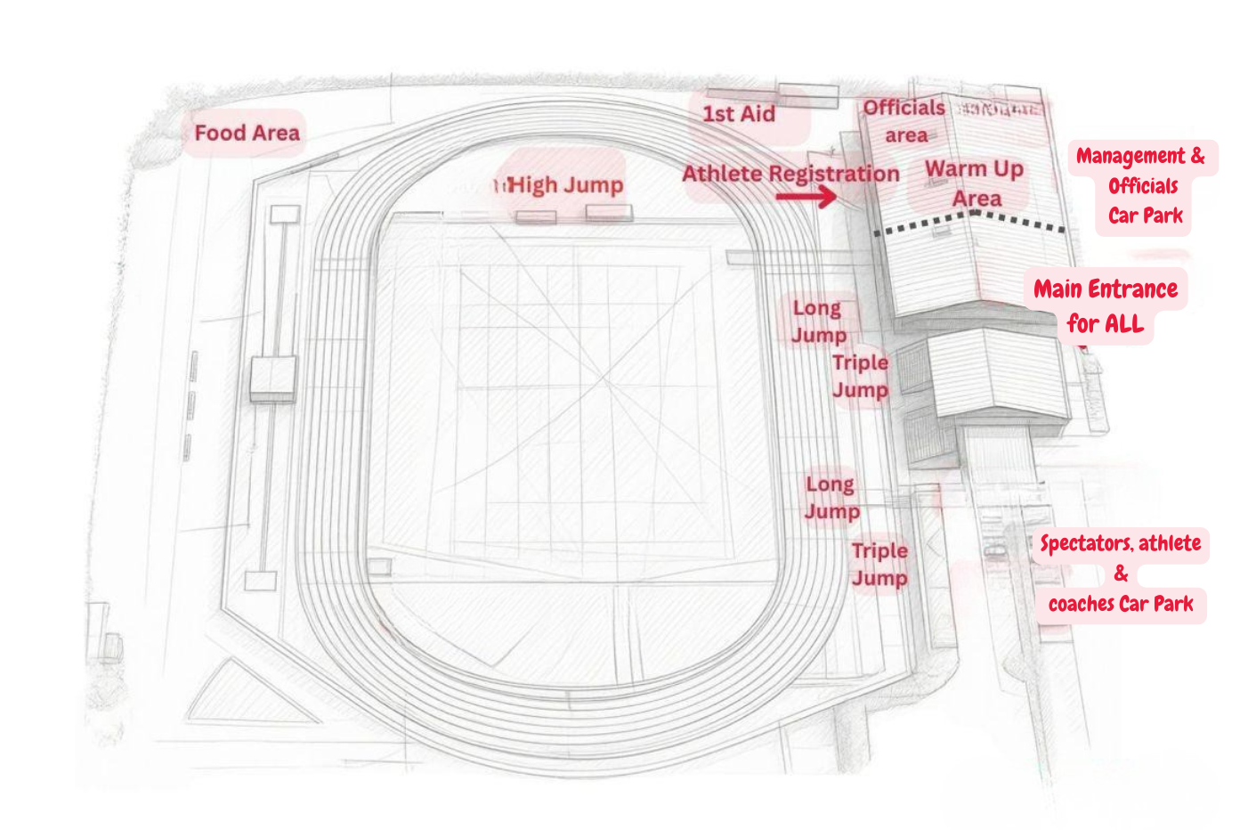
Bedford Site Map – 29th August 2026

Listed below are all the relevant documents that are/will be available on the website. Please look at the web site (BIG on TOUR Home & venues page) regularly as any updates or information will be posted there.

We look forward to seeing you on August 29th and hope that you enjoy the day with a host of great competitions. There is a Feedback QR code for the series and we would be grateful if you could complete it giving constructive comments on the day and how we can move the series forward Early competition would be appreciated so we have time to implement any changes before next year.

Many thanks for your support. Enjoy the day.

Please do not hesitate to contact me if there are any other questions.

With best wishes,

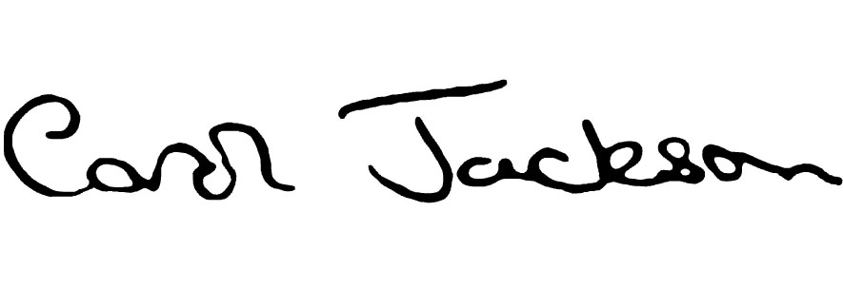
Carol Jackson
Meeting Director
07850 190299
carol@gobiguk.net

On https://www.bedfordgames.co.uk/bedfordfinal6

Officials List Officials Letter Timetable

Athlete Letter Entries Lists Competition Pools

