

BIG on TOUR 2026 (Series 4) & SBH Jumps Fest
Sunday July 19th
StoneX Stadium, Hendon

Field Official

Dear Official

Many thanks for agreeing to officiate at our the 4th in the BIG on TOUR 2026 series. I would like to thank you for supporting us as we launch this very exciting initiative to help provide good quality competition for High Jumpers & Long Jumpers in a fun, friendly and well officiated environment.

We are running this in conjunction with Shaftesbury Barnet Jumps Fest. PLEASE NOTE that due to lowish numbers and a shortage of officials in both events James & I have decided to combine the two. This letter is therefore going to Officials who may not know anything about BIG on TOUR. You can find much more on www.bedfordgames.co.uk and follow the BIG on TOUR links. Please be assure we are a friendly group, working for the best athlete experience possible and will provide training in the use of EDM, wind Guage, No Jump cameras and IPad results input.

BIG on TOUR is a series of 6 competitions focussing on only High Jump & Long Jump and spread throughout the South & Midlands over the whole of the summer with a Final being held in Bedford on 29th August (more details can be found on the BIG on TOUR section of our website if you would like to know more). We hope it will fill a gaping hole in this area and allow more athletes to gain qualifying standards for the European Champs in Birmingham, World U20’s in Oregon and European U18’s Champs in Rieti, Italy.

We have been given a Level 2 Permit and World Ranking point Level F as well as WPA status.

The events this year are High Jump and Long Jump. As is our trademark, BIG on TOUR will also be an athlete friendly meeting with coaching areas close to the events (roped off for safety of course).

We are PILOTING the TOUR this year with some new procedures or protocols you may not be familiar with so things may be a little strange or crazy at times but here are a few things I think it would be good for you to know.
- There will be no CALL UP area – athletes will report to their event site 30 minutes before their Pool start time.
- Please can the Chiefs of each competition check athletes spike length, disallowed equipment, etc. at the event site.
- We have Lead Officials whose responsibilities will be MM , FR & EO before the meeting and they will return to Field Judges when we begin. These officials and others present have worked with us at BIG before and who know the protocols and they will be there to act as Mentors to any new officials we have.
- We have also invited a small number of Level 1 and Level 2 officials to work alongside us in a high level competition environment & work with technical equipment (Tablet recording, No Jump Cameras, EDM, etc) which they may be unfamiliar with. Training will be given on these as required.
- Technical equipment will be around the stadium (touch screens, electronic scoreboards, etc).
- A Local Organiser is being appointed for each venue and they will have the job of overseeing everything on the day
- All results will be recorded on Tablets and these will go directly to electronic scoreboards at each event, the bigger screen around the arena and Power of 10 (if it is working by then!)

All final paperwork (Officials list, Timetables, Entry lists and Athlete letter) will also be available through the https://www.bedfordgames.co.uk/stonex4 (look at the drop-down boxes to the top Right of the home page or go via the button on the home page) and will be amended / added to as appropriate so please recheck regularly.

LEAD OFFICIALS - We have identified the following Leads to start and close the event. However they will return to Field / Mentoring roles once the event begins

Claire Lacey (MM) Jackie Breslin (FRef)

CAR PARK – There is plenty of space in the large car park and this is free for all. Disabled parking is also available.

OFFICIALS’ ARRIVAL – please bring your UKA Officials Licence on your blue lanyard. PLEASE arrive by 09.00. On arrival please go to the Officials’ Registration desk in the Indoor area near the Athlete Registration Desk. A Briefing will be held at 09.15 on HJ Fan.

OFFICIALS’ DRESS - Officials are required to wear NAVY BLUE or BLACK trousers/skirts (NO shorts please), white polo shirts and navy fleece / navy jumper. Please wear your BIG POLO SHIRT if you still have one! A Professional appearance reassures athletes we are running a tight ship whilst providing everything the athletes need. Thank you.

REFRESHMENTS / FOOD ALLOWANCE - Tea and Coffee will be available but please would you bring your own mug. SBH are going to be providing Officials food but if you have an Allergy please let me know and I will give you a £5 per Diem food allowance. There is a Café in the Main Stand providing hot food and sandwiches as well as teas and coffees and hopefully Ice Creams! Though the forecast is a little kinder next Sunday.

WA RULES - Please note that the meeting will be run under WA rules. We have a Level 2 UKA Licence & World Athletics status. However, can I please ask that we work within the spirit of the meeting.

TECHNICAL EQUIPMENT – An EDM unit, wind gauge and No Jump Camera has been booked for use on Long Jump. Electronic Clocks and Scoreboards have also been booked for all sites.

TECH SUPPORT – We will be using TABLETS for recording results at all event sites this year with direct links to the EDM and the results package as well as to the electronic screens at each site. These are being provided by Paul Day at Tech4sports. His 5G Wi-Fi will guarantee these will work. Paul & Jess will also be there to ensure the smooth running of this. N.B. Please do not worry if you have not used this equipment before training will be provided.

TIMETABLE - With just 2 events this is quite simple and we do not expect any changes but will keep you posted with updates / changes on https://www.bedfordgames.co.uk/stonex4. 1st event 10.30, finish approx. 16.30.

VENUE INFORMATION - The Athlete & Coaches Registration area will be situated at the far end of the Indoor Track. The Officials area is also close to this. We are hoping the HJ will be on the top bend and the LJ pit is on the raised bank above the top bend.- direction will be wind dependent. This will ensure a better atmosphere and less walking between events for ME!!! However this is dependent on a small repair needed for the surface being completed in time

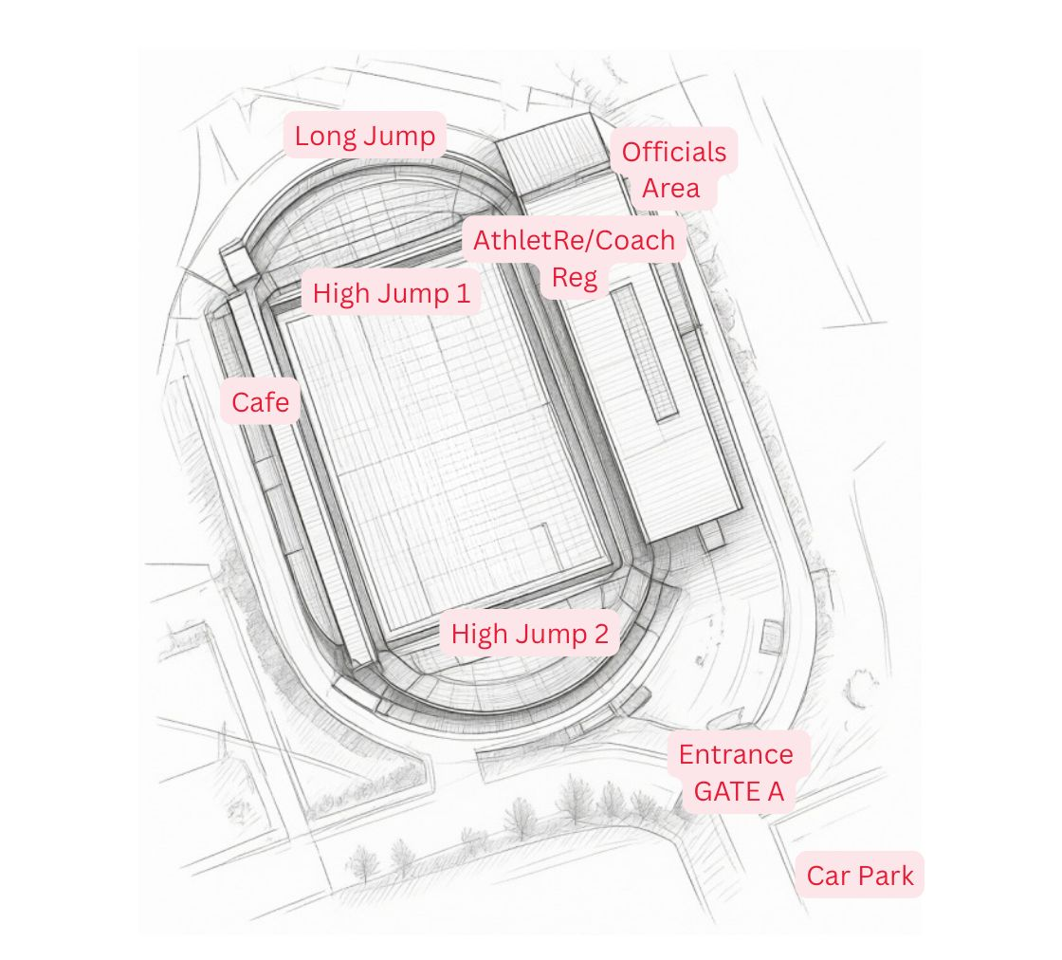Hendon Site Map

Listed below are all the relevant documents that are/will be available on the website. Please look at the web site (BIG on TOUR Home & venues page) regularly as any updates or information will be posted there.

We look forward to seeing you on July 19th and hope that you enjoy the day with a host of great competitions. There is a Feedback QR code for the series and we would be grateful if you could complete it giving constructive comments on the day and how we can move the series forward Early competition would be appreciated so we have time to implement any changes before the next event.

Many thanks for your support. Enjoy the day.

Please do not hesitate to contact me if there are any other questions.

With best wishes,

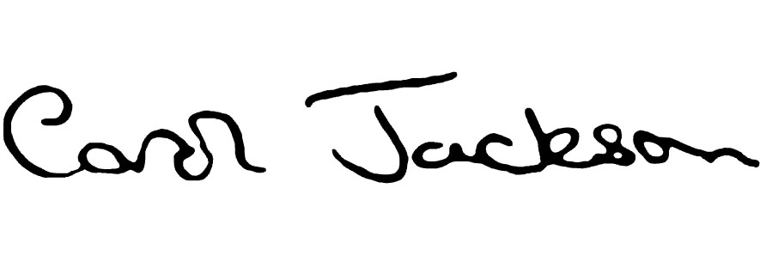
Carol Jackson
Meeting Director
07850 190299
carol@gobiguk.net

On https://www.bedfordgames.co.uk/leevalley1

Officials List Officials Letter Timetable

Athlete Letter Entries Lists Competition Pools

